Identity Verification

🧾 What is Identity Verification?
# Source: AI Source: Provided by: [Data Path: Persons Table -> ID Column: 1, Name_En Column: Motasem Essam] -> From: [Chatgpt (GPT‑5 Mini)] on [1/20/2026]
Identity verification is the process of confirming that someone is truly who they claim to be. It’s used to prevent fraud, protect user accounts, and comply with legal regulations (like KYC, AML, GDPR).

🧍‍♂️ Why Identity Verification Matters
# Source: AI Source: Provided by: [Data Path: Persons Table -> ID Column: 1, Name_En Column: Motasem Essam] -> From: [Chatgpt (GPT‑5 Mini)] on [1/20/2026]
✅ Helps prevent:
- Fake account creation
- Identity theft
- Money laundering
- Unauthorized access
✅ Used in:
- Banking and fintech apps
- E-commerce & payment gateways
- Government & healthcare services
- Crypto exchanges
- Social platforms

🔍 Common Methods of Identity Verification
# Source: AI Source: Provided by: [Data Path: Persons Table -> ID Column: 1, Name_En Column: Motasem Essam] -> From: [Chatgpt (GPT‑5 Mini)] on [1/20/2026]
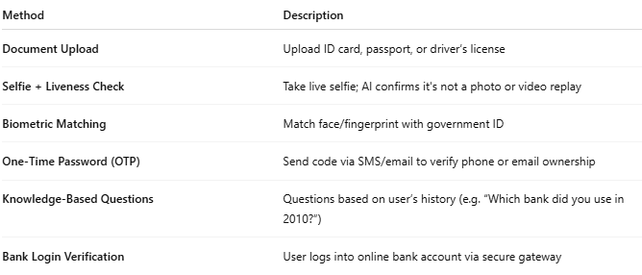

Method | Description
Document Upload | Upload ID card, passport, or driver’s license
Selfie + Liveness Check | Take live selfie; AI confirms it's not a photo or video replay
Biometric Matching | Match face/fingerprint with government ID
One-Time Password (OTP) | Send code via SMS/email to verify phone or email ownership
Knowledge-Based Questions | Questions based on user’s history (e.g. “Which bank did you use in 2010?”)
Bank Login Verification | User logs into online bank account via secure gateway

📦 Identity Verification API Providers
# Source: AI Source: Provided by: [Data Path: Persons Table -> ID Column: 1, Name_En Column: Motasem Essam] -> From: [Chatgpt (GPT‑5 Mini)] on [1/20/2026]
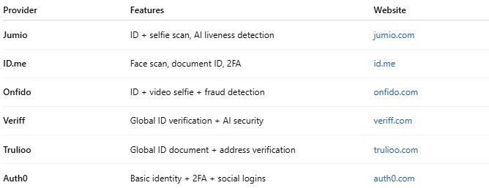

Provider | Features | Website
Jumio | ID + selfie scan, AI liveness detection | jumio.com
ID.me | Face scan, document ID, 2FA | id.me
Onfido | ID + video selfie + fraud detection | onfido.com
Veriff | Global ID verification + AI security | veriff.com
Trulioo | Global ID document + address verification | trulioo.com
Auth0 | Basic identity + 2FA + social logins | auth0.com

🔐 Example Use Case
# Source: AI Source: Provided by: [Data Path: Persons Table -> ID Column: 1, Name_En Column: Motasem Essam] -> From: [Chatgpt (GPT‑5 Mini)] on [1/20/2026]
- 🧍 User signs up for a crypto wallet
- 📷 Uploads passport + takes a selfie
- 🧠 System checks face match and document validity
- ✅ If passed → Account is approved
- ❌ If failed → Ask for re-verification

🔄 Identity Verification vs. Authentication
# Source: AI Source: Provided by: [Data Path: Persons Table -> ID Column: 1, Name_En Column: Motasem Essam] -> From: [Chatgpt (GPT‑5 Mini)] on [1/20/2026]
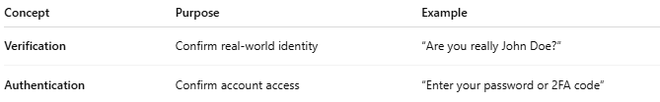

Concept | Purpose | Example
Verification | Confirm real-world identity | “Are you really John Doe?”
Authentication | Confirm account access | “Enter your password or 2FA code”

